Pokhara University

Level: Bachelor | Semester – Fall | Year : 2009
Programme: Architecture |  | Full Marks : 100
Course: Structure I |  | Time : 3hrs.

Candidates are required to give their answers in their own words as far as practicable.
The figures in the margin indicate full marks.

Attempt all the questions.

1. | - Discuss different types of support and support reactions with suitable sketches.  - A torque of 5k-N –m is acting on a circular shaft of 100mm in diameter and 2m in length. Calculate the maximum shear stress developed in the shaft and angle of twist. | 8  7
2. | - A tensile load of 100kN is acting on rod of 50mm diameter and length of 5m. Determine the length of a bore of 25mm that can be made central in the rod if the total extension is not to exceed by 25 percent under same tensile load. Take E = 2.1×10⁵ N/mm².  - A steel tube of cross sectional area 2 cm² encloses a straight copper rod of cross-sectional area of 1.8cm². Both the rod and the tube are concentrically placed and are rigidly connected at the ends. At a temperature of 20⁰ C, there is no longitudinal stress. Calculate the thermal stresses in the rod and the tube if they are heated to a temperature of 200⁰C. Find the change in length if the initial length at 20⁰ C is 10cm. Assume E_{s} = 200GN/m², E_{c} = 90 GN/m², α_{s} = 12×10⁻⁶ /⁰C. | 7  8
3. | Calculate moment of inertial about given x-axis and y-axis of the plane area given below. Also calculate radii of gyration.  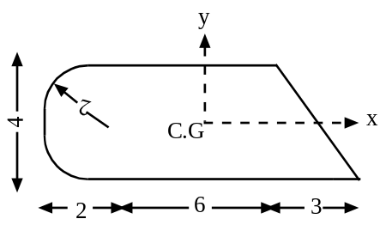 | 15
4. | A truss is loaded as shown in the figure below. Determine the forces in all the members of the truss.  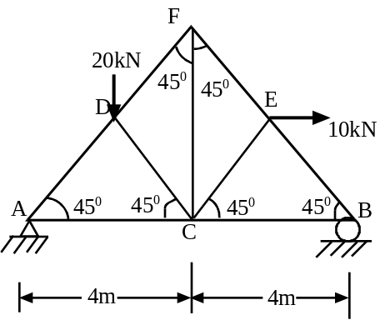 | 15
5. | - Draw shear force diagram and bending moment diagram of the given loaded beam.  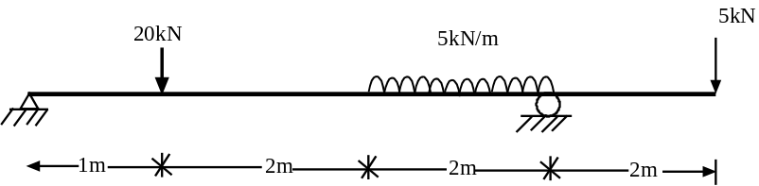  - Derive relation between load, shear force and bending moment.  OR  - Derive the relation, 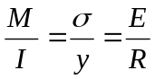where, all symbols have their as usual meaning.  - A simply supported beam is 5m in length and 100mm wide & 200mm deep. Calculate the maximum point load it can carry at the mid of the span, if permissible stress in tension is 8N/mm² and permissible stress in compression is 10N/mm². | 10  5  8  7
6. | - Write down Eulers formula to calculate critical load in slender column for the different end conditions.  - A simply supported beam 150mm wide and 300mm deep is 5m in length and is carrying a uniformly distributed load of 5kN/m. Calculate maximum bending tension and compression stresses developed in the section. | 7  8
7. | Write short notes on (Any Two)  - Slenderness ratio  - Generalized Hooke's law  - Radius of gyration | 5×2

